Topic 4.3

ACIDS AND BASES

Bronsted-Lowry theory
Acids and bases in water
Calculating pH
Buffer solutions
Acid-alkali titrations
Indicators

BRONSTED-LOWRY ACIDS AND BASES

1. The Bronsted-Lowry definition

There are many definitions of acids and bases in existence, but the most useful one is the Bronsted-Lowry definition:

An acid is a substance which can behave as a proton donor. A proton can be represented as a hydrogen ion, H⁺.
Any substance which contains hydrogen bonded to a more electronegative element can thus behave as an acid:

HCl == H⁺ + Cl⁻
H₂SO₄ == H⁺ + HSO₄⁻
CH₃COOH == H⁺ + CH₃COO⁻

A base is a substance which can behave as a proton acceptor. Any species which has a lone pair of electrons can thus behave as a base:

NH₃ + H⁺ == NH₄⁺
OH⁻ + H⁺ == H₂O
CO₃²⁻ + H⁺ == HCO₃⁻

2. Conjugate acid-base pairs

Since all the above reactions are reversible, the species formed when an acid gives up a proton can accept a proton and thus behave as a base. The species formed when a base accepts a proton can give up a proton and behave as an acid:

Cl⁻ + H⁺ == HCl
HSO₄⁻ + H⁺ == H₂SO₄
CH₃COO⁻ + H⁺ == CH₃COOH

NH₄⁺ == NH₃ + H⁺
H₂O == H⁺ + OH⁻
HCO₃⁻ == H⁺ + CO₃²⁻

Acids and bases thus come in pairs; every acid can lose a proton to become a base and every base can accept a proton to become an acid. Species related in this way are known as conjugate acid-base pairs.
Eg Cl⁻ is the conjugate base of HCl; HCl is the conjugate acid of Cl⁻
Eg NH₃ is the conjugate base of NH₄⁺; NH₄⁺ is the conjugate acid of NH₃

Not all acids are equally good proton donors; in fact some give up their protons very reluctantly; conversely, some bases accept protons readily whereas others accept protons very reluctantly.

The better an acid is at losing protons, the worse its conjugate base will be at accepting them. The better a base is at accepting protons, the worse its conjugate acid will be at losing them. Thus a strong acid will have a weak conjugate base, and a weak acid will have a strong conjugate base.

Acids and bases can be ranked in order of decreasing strength; a list of common acids and their conjugate bases ranked in such a way is shown below:

ACID |  | BASE
H₂NO₃⁺ (NO₂⁺ + H₂O) | == | HNO₃ | + H⁺
H₂SO₄ | == | HSO₄⁻ | + H⁺
HNO₃ | == | NO₃⁻ | + H⁺
HCl | == | Cl⁻ | + H⁺
H₃O⁺ | == | H₂O | + H⁺
H₂SO₃ (SO₂ + H₂O) | == | HSO₃⁻ | + H⁺
HSO₄⁻ | == | SO₄²⁻ | + H⁺
H₃PO₄ | == | H₂PO₄⁻ | + H⁺
HF | == | F⁻ | + H⁺
HNO₂ | == | NO₂⁻ | + H⁺
CH₃COOH | == | CH₃COO⁻ | + H⁺
H₂PO₄⁻ | == | HPO₄²⁻ | + H⁺
H₂CO₃ (CO₂ + H₂O) | == | HCO₃⁻ | + H⁺
HSO₃⁻ | == | SO₃²⁻ | + H⁺
NH₄⁺ | == | NH₃ | + H⁺
HCN | == | CN⁻ | + H⁺
HCO₃⁻ | == | CO₃²⁻ | + H⁺
HPO₄²⁻ | == | PO₄³⁻ | + H⁺
H₂O | == | OH⁻ | + H⁺
OH⁻ | == | O²⁻ | + H⁺

The strongest acids are at the top; these have the weakest conjugate bases.

The strongest bases are at the bottom; these have the weakest conjugate acids.

Note that some species (eg H₂O, HSO₃⁻, HCO₃⁻ amongst others) appear in both columns. Such species can behave as either acids or bases and are said to be amphoteric.

3. Acid-base reactions

Protons are not given up by acids unless there is a base which can accept them; and bases can only accept protons if there is an acid present to provide them. Reactions between acids and bases thus involve proton transfer from acid to base.

In acid-base reactions, acids react with bases to give the conjugate base of the reactant acid and the conjugate acid of the reactant base. The reactant acid is given the label "acid 1" and its conjugate base is given the label "base 1". The reactant base is given the label "base 2" and its conjugate acid is given the label "acid 2".

A general acid-base reaction can thus be represented as follows:
Acid 1 + Base 2 == Base 1 + Acid 2

Eg HCl + H₂O == H₃ O⁺ + Cl⁻
Acid 1 Base 2 Acid 2 Base 1

Eg NH₃ + H₂O == NH₄⁺ + OH⁻
Base 1 + Acid 2 Acid 1 Base 2

Eg O²⁻ + H₂O == OH⁻ + OH⁻
Base 1 + Acid 2 Acid 1 + Base 2

Eg H₃O⁺ + OH⁻ == H₂O + H₂O
Acid 1 Base 2 Base 1 Acid 2

Amphoteric substances can undergo acid-base reactions with themselves:

Eg H₂O + H₂O == H₃O⁺ + OH⁻
Acid 1 + Base 2 Base 1 Acid 2

Eg HCO₃⁻ + HCO₃⁻ == CO₃²⁻ + CO₂ + H₂O
Acid 1 Base 2 Base 1 Acid 2

Any acid-base reaction which takes place in aqueous solution will reveal which of two acids is the stronger:

Eg HCl(aq) + H₂O(l) → H₃O⁺(aq) +Cl⁻(aq) goes 95%
So HCl is a stronger acid than H₃O⁺

CH₃COOH(aq) + H₂O(l) → CH₃COO⁻(aq) + H₃O⁺(aq) only goes 1%
So H₃O⁺ is a stronger acid than CH₂COOH

CO₃²⁻(aq) + SO₂(aq) [+ H₂O(l)] → CO₂(aq) [+ H₂O(l)] + SO₃²⁻(aq) goes 90%
So SO₂ is a stronger acid than CO₂
ACIDS AND BASES IN WATER

Most common acid-base reactions take place in aqueous solution, and thus acids and bases are generally defined by the way in which they react with water.

- Auto-ionisation of water

Water can behave both as an acid and a base: in aqueous solution a small fraction of the water molecules undergo acid-base reactions with each other to produce the equilibrium:
2H₂O(l) == H₃O⁺(aq) + OH⁻(aq)

This is known as the auto-ionisation of water. The equilibrium expression for this reaction can be written:

K_{c} = [H₃O⁺][OH⁻]
[H₂O]²

The concentration of water under these conditions is not changed significantly, since the proportion of water which dissociates into its ions is small. The water concentration can thus be assumed to be constant and it can be incorporated into K_{c}:
K_{w} = [H₃O⁺][OH⁻]
K_{c}[H₂O] = K_{w} = [H₃O⁺][OH⁻]

The expression [H₃O⁺][OH⁻] is known as the ionic product of water and has a value of 1.0 x 10⁻¹⁴ mol²dm⁻⁶ at 25ºC. This value is a constant at a given temperature. The ionic product of water is slightly higher at higher temperatures, suggesting that the dissociation is endothermic.

In pure water, the [H₃O⁺] and [OH⁻] concentrations are equal.
It follows that [H₃O⁺][OH⁻] = [H₃O⁺]² = K_{w}.
So [H₃O⁺] = [OH⁻] = K_{w} = 1.0 x 10⁻⁷ moldm⁻³.

Any solution in which the concentrations of H₃O⁺ and OH⁻ are equal is said to be neutral.

- Acidic and alkaline solutions

An acid can be regarded as a substance which reacts with water by forcing it to accept a proton and behave as a base:

HA(aq) + H₂O(l) == H₃O⁺(aq) +A⁻(aq)

The resulting solution contains an excess of H₃O⁺ ions. Any solution which contains more H₃O⁺ ions than OH⁻ ions is said to be acidic. The measure of the acidity of the solution is the H₃O⁺ concentration. The greater the H₃O⁺ concentration, the more acidic the solution.

A base can be regarded as a substance which reacts with water by accepting a proton from water, forcing it to behave as an acid:

B⁺(aq) + H₂O(l) == BH⁺(aq) + OH⁻(aq)

The resulting solution contains an excess of OH⁻ ions. Any solution which contains more OH⁻ ions than H₃O⁺ ions is said to be alkaline. The measure of the alkalinity of the solution is the OH⁻ concentration. The greater the OH⁻ concentration, the more alkaline the solution.

The concentration of OH⁻ ions can be deduced from the concentration of H₃O⁺ ions and vice versa. The following table shows some examples:

[H₃O⁺] | [OH⁻] | Type of solution
0.1 | 1 x 10⁻¹³ | Acidic
1 x 10⁻³ | 1 x 10⁻¹¹ | Acidic
1 x 10⁻⁵ | 1 x 10⁻⁹ | Acidic
1 x 10⁻⁷ | 1 x 10⁻⁷ | Neutral
1 x 10⁻⁹ | 1 x 10⁻⁵ | Alkaline
1 x 10⁻¹¹ | 1 x 10⁻³ | Alkaline
1 x 10⁻¹³ | 0.1 | Alkaline

- The pH scale

The acidity and alkalinity of a solution is often measured by its pH.

The pH of a solution is the negative logarithm to the base ten of the H₃O⁺ concentration. pH = -log₁₀[H₃O⁺].
pH = -log₁₀[H₃O⁺]
If [H₃O⁺] = 1.0M, the pH of the solution is 0.
If [H₃O⁺] = 0.1M, the pH of the solution is 1.
If [H₃O⁺] = 0.01M, the pH of the solution is 2.

In alkaline solutions, the OH⁻ concentration is known. The concentration of H₃O⁺ can be deduced from the ionic product of water:
[H₃O⁺][OH⁻] = 1.0 x 10⁻¹⁴ mol²dm⁶. [H₃O⁺] = K_{w}/[OH⁻].

If [OH⁻] = 1.0M, [H₃O⁺] = 1 x 10⁻¹⁴ M and the pH of the solution is 14.
If [OH⁻] = 0.1M, [H₃O⁺] = 1 x 10⁻¹³ M and the pH of the solution is 13.
If [OH⁻] = 0.01M, [H₃O⁺] = 1 x 10⁻¹² M and the pH of the solution is 12.

Note that an increase in pH of one unit is equivalent to a tenfold fall in the H₃O⁺ concentration, and a decrease in pH of one unit is equivalent to a tenfold increase in the H₃O⁺ concentration.

Calculating the pH of water:

In pure water, [H₃O⁺] = [OH⁻] = 1 x 10⁻⁷ M and the pH = 7.
It follows that the pH of acidic solutions is less than 7 and the pH of alkaline solutions is greater than 7.

At higher temperatures, the ionic product of water is greater and [H₃O⁺] is greater than 1 x 10⁻⁷ M. The pH of pure water is thus slightly less than 7 at higher temperatures. The solution is still neutral, since the concentrations of H₃O⁺ and OH⁻ are still the same. The pH of a neutral solution is just lower at higher temperatures.
STRONG AND WEAK ACIDS

Acids can be classified as one of two types; strong acids and weak acids. Each must be considered separately:

1. Strong acids

A strong acid is one which dissociates completely in water into H₃O⁺ and A⁻. A strong acid must therefore be a better proton donor than H₃O⁺. Examples of strong acids are HCl, HNO₃ and H₂SO₄.

Calculating the pH of strong acids:

Since strong acids dissociate fully, the concentration of H₃O⁺ will be the same as the concentration of the acid (ignoring the auto-ionisation of water).
A 1.0M solution of HCl will therefore be 1.0M with respect to both H₃O⁺ and Cl⁻ ions if the H₃O⁺ present due to the auto-ionisation of water (which will be small in comparison) is ignored:
HCl(aq) + H₂O(l) → H₃O⁺(aq) + Cl⁻(aq)
1.0M 1.0M

The pH of 1.0M HCl is thus 0.

If [H₃O⁺] = 1.0M, the pH of 1.0M HCl is thus 0.

The [H₃O⁺] in a 0.10M solution of HCl is 0.10M. The pH of 0.10M HCl is thus 1.
The [H₃O⁺] in a 0.05M solution of HCl is 0.05M. The pH of 0.05M HCl is thus 1.3.
The [H₃O⁺] in a 2M solution of HCl is 2M. The pH of 2M HCl is thus -0.3.

In theory, there is no minimum pH as the molarity of the acid can increase indefinitely. In practice, the pH rarely falls below -0.5 as even strong acids do not dissociate fully at very high concentrations (there is not enough water). Strong acids can thus only be said to be fully dissociated if the solution is reasonably dilute (ie less than 0.1M).

Diluting the acid tenfold causes the pH to rise by one unit.

2. Weak acids

A weak acid is one which only dissociates partially in water. It reaches equilibrium as follows:

HA(aq) + H₂O(l) == H₃O⁺(aq) + A⁻(aq)
C-x x x

A weak acid is one which is a worse proton donor than H₃O⁺. Examples are CH₃COOH (ethanoic acid), NaHSO₄ (sodium hydrogensulphate) and CO₂ (carbon dioxide).

The equilibrium expression for the dissociation of a weak acid is as follows:

K_{c} = [H₃O⁺][A⁻]
[HA][H₂O]
The water is in large excess, so its concentration is not significantly affected by this equilibrium and so can be assumed to remain constant. The equilibrium expression can thus be re-written:

K_{c}[H₂O] = K_{a} = [H₃O⁺][A⁻]
K_{a} = [H₃O⁺][A⁻]
[HA]

[HA]

K_{a} is known as the acid dissociation constant for the acid and has units of moldm⁻³.
It is often quoted as pK_{a} = -log₁₀K_{a}.
pK_{a} = -log₁₀K_{a}

Some K_{a} and pK_{a} values for different acids are shown below:

ACID | K_{a}/moldm⁻³ | pK_{a}
HSO₄⁻ | 1.0 x 10⁻² | 2.0
CH₃COOH | 1.7 x 10⁻⁵ | 4.8
CO₂ + H₂O | 4.5 x 10⁻⁷ | 6.3
NH₄⁺ | 5.8 x 10⁻¹⁰ | 9.2
HCO₃⁻ | 4.8 x 10⁻¹¹ | 10.3

The larger the K_{a}, the greater the degree to which the acid dissociates into its ions and the stronger the acid.

Calculating the pH of weak acids

The H₃O⁺ concentration can be calculated by the following method:

HA(aq) + HO(l) == H₃O⁺(aq) + A⁻(aq)
C-x x x

K_{a} = [H₃O⁺][A⁻]
[HA]

Ignoring the H₃O⁺ present due to the auto-ionisation of water, the H₃O⁺ and A⁻ concentrations can be assumed to be the same. Therefore [H₃O⁺][A⁻] = [H₃O⁺]².

If the degree of dissociation of HA is assumed to be small, then the molarity of the HA can be assumed to be the same as that of the solution (assume C-x is approximately equal to C).

K_{a} = [H₃O⁺]² so [H₃O⁺]² = K_{a}[HA] and [H₃O⁺] =√ K_{a}[HA]
[HA]

eg Calculate the pH of 0.1 moldm⁻³ ethanoic acid, K_{a} = 1.7 x 10⁻⁵ moldm⁻³

CH₃COOH(aq) + H₂O(l) == CH₃COO⁻ + H₃O⁺(aq)

K_{a} = [H₃O⁺][ CH₃COO⁻]
[CH₃COOH]
Ignoring auto-ionisation of water, [H₃O⁺] = [CH₃COO⁻] so
[H₃O⁺][CH₃COO⁻] = [H₃O⁺]².
Assuming degree of dissociation of CH₃COOH is small, [CH₃COOH] = 0.1 moldm⁻³.

[H₃O⁺]² = K_{a} x 0.1, so [H₃O⁺] = √K_{a} x 0.1 = 1.304 x 10⁻³ moldm⁻³ and pH = 2.9

By the same method, the pH of 0.01M CH₃COOH can be shown to be 3.4, and the pH of 0.001M CH₃COOH can be shown to be 3.9.

Note that when a weak acid is diluted tenfold, the pH does not increase by one unit as expected. In fact it increases only by 0.5 units. This suggests that the weak acid compensates for the dilution by dissociating to a greater extent:
In 0.1M ethanoic acid, approximately 1.3% of the molecules are dissociated into ions.
In 0.01M ethanoic acid, approximately 4.1% of the molecules are dissociated into ions.
In 0.001M ethanoic acid, approximately 13% of the molecules are dissociated into ions.

Thus the more dilute the solution, the greater the extent to which the acid dissociates into its ions. This is in accordance with Le Chatelier's principle:

HA(aq) + H₂O(l) == H₃O⁺(aq) + A⁻(aq)

As the amount of water increases, the equilibrium is shifted to the right and the degree of dissociation is greater. This is not the case with strong acids, since they are fully dissociated even at relatively high concentrations and are thus unable to respond to dilution in the same way.

- Acidic salts

Salts of weak bases can behave as acids.
Examples of acidic salts are: NH₄⁺(aq), Al³⁺(aq), Fe³⁺(aq)
Expressions for K_{a} are deduced in the normal way:

NH₄⁺(aq) + H₂O(l) == NH₃(aq) + H₃O⁺(aq) | K_{a} = [NH₃][H₃O⁺]  [NH₄⁺]
[Al(H₂O)₆]³⁺ + H₂O(l) == [Al(H₂O)₅(OH)]²⁺ + H₃O⁺(aq) | K_{a} = [[Al(H₂O)₅(OH)]²⁺][H₃O⁺]  [[Al(H₂O)₆]³⁺]
[Fe(H₂O)₆]³⁺ + H₂O(l) == [Fe(H₂O)₅(OH)]²⁺ + H₃O⁺(aq) | K_{a} = [[Fe(H₂O)₅(OH)]²⁺][H₃O⁺]  [[Fe(H₂O)₆]³⁺]

- Dilute and concentrated solutions

A dilute solution of an acid is a solution with a low molarity (eg 0.001M HCl). A concentrated solution of an acid is a solution with a high molarity (eg 1M CH₃COOH).

It is impotant to realise that the concentration of the solution is not necessarily a good measure of the acidity of the solution, since concentrated solutions of weaker acids may be less acidic than more dilute solutions of stronger acids:

Eg the pH of 0.1 M CH₃COOH (K_{a} = 1.7 x 10⁻⁵ M) is 2.88, but the pH of 0.05 M HCOOH (K_{a} = 1.6 x 10⁻⁴ M) is 2.55.
Thus the solution of HCOOH is more acidic, even though it is more dilute. This is because it is a stronger acid (ie it has a larger K_{a}) and so dissociates to a greater extent.

It is not, however, always true that the stronger acid will give the more acidic solution. Often concentrated solutions of weaker acids are more acidic than more dilute solutions of stronger acids:

Eg the pH of 0.1M CH₃COOH (K_{a} = 1.7 x 10⁻⁵ M) is 2.88, but the pH of 0.001M HCl is 3.0. Thus the solution of CH₃COOH is more acidic, even though it is a weaker acid. This is because the molar concentration of the acid is higher.

The acidity of a solution (ie the concentration of H₃O⁺) therefore depends on both the concentration of the solution and the strength of the acid.

5. Very dilute solutions

In all the calculations considered so far, the H₃O⁺ present due to the auto-ionisation of water has been ignored. This is normally a reasonable assumption, since water only ionises very slightly ([H₃O⁺]= 1 x 10⁻⁷ M in pure water).

In very dilute solutions, however, the H₃O⁺ present due to the auto-ionisation of water is significant and cannot be ignored. This is generally the case if the concentration of the solution is less than 1 x 10⁻⁶ M.

The pH of 1 x 10⁻⁶ M HCl = 6.00
The pH of 1 x 10⁻⁷ M HCl is not, however, equal to 7, since the solution is very slightly acidic, and the pH of 1 x 10⁻⁸ M HCl is certainly not 8.

At such low concentrations the H₃O⁺ present due to the auto-ionisation of water is significant and must be taken into consideration.
From a more thorough consideration of the equilibrium mixture, it can be shown that the pH of a 1 x 10⁻⁷M solution of HCl is 6.79 and the pH of a 1 x 10⁻⁸ M solution of HCl is 6.98.
6. polybasic acids

Acids which are capable of losing more than one proton are said to be polybasic. Examples of polybasic acids are H₂SO₄, H₃PO₄ and CO₂ + H₂O.
Acids which can lose two protons in solution are said to be dibasic, and acids which can lose three protons in solution are said to be tribasic.

Polybasic acids dissociate more than once in aqueous solution:

Eg H₂SO₄(aq) + H₂O(l) == H₃O⁺(aq) + HSO₄⁻(aq)
HSO₄⁻(aq) + H₂O(l) == H₃O⁺(aq) + SO₄²⁻(aq)

Each H₂SO₄ therefore gives two moles of H₃O⁺ ions

Polybasic acids such as H₂SO₄ thus form more than one salt; H₂SO₄, a dibasic acid, forms two sodium salts, NaHSO₄ and Na₂SO₄. H₃PO₄, a tribasic acid, forms three sodium salts, NaH₂PO₄, Na₂HPO₄ and Na₃PO₄.

The number of protons which an acid loses can be determined from its reaction with alkali:
H_{x}A(aq) + xNaOH(aq) → Na_{x}A(aq) + xH₂O(l)
Monoprotic acids react with sodium hydroxide in a 1:1 ratio.
Diprotic acids react with sodium hydroxide in a 2:1 ratio.
Triprotic acids react with sodium hydroxide in a 3:1 ratio, etc.

With many acids, not all of the available hydrogen is lost and the thus the number of replaceable hydrogens must be determined experimentally:
H₃BO₃ reacts with NaOH in a 1:1 ratio, so H₃BO₃ is monobasic:
H₃BO₃(aq) + NaOH(aq) → NaH₂BO₃(aq) + H₂O(l)
H₃PO₃ reacts with NaOH in a 1:2 ratio, so H₃PO₃ is dibasic:
H₃PO₃(aq) + 2NaOH(aq) → NaHPO₃(aq) + 2H₂O(l)

BASES

1. Strong bases

A strong base is one which fully dissociates into its ions in water:
B(aq) + H₂O(l) → BH⁺(aq) + OH⁻(aq)
Eg O²⁻(aq) + H₂O(l) → 2OH⁻(aq)

A strong base in water must therefore be a stronger base than OH⁻.

Strong bases in water are, in fact, quite rare as water is a very weak acid and will not readily give up protons to other species. The oxide ion is one of the only common examples of a strong base.

The hydroxide ion is, however quite stable and there are many examples of ionic substances containing OH⁻ ions. If these substances are soluble, they will completely dissociate in aqueous solution. Though they do not actually react with water, they are regarded as strong bases since they completely dissociate to give OH⁻ ions. Exmples of these substances are NaOH, KOH and Ba(OH)₂.

Substances which dissolve in water to produce an excess of OH⁻ ions are said to be alkaline.

Calculating the pH of strong bases:

The pH of strong bases can be calculated if the concentration of the solution is known:

Eg 0.1M NaOH: [OH⁻] = 0.1M, so [H₃O⁺] = K_{w}/[OH⁻] = K_{w}/0.1 = 1 x 10⁻¹³ M.
Thus the pH of 0.1M NaOH is 13.0

Eg 0.1M Ba(OH)₂: [OH⁻] = 0.2M, so [H₃O⁺] = 5 x 10⁻¹⁴ M.
Thus the pH of 0.1M Ba(OH)₂ = 13.3

Note that in these calculations the OH⁻ present due to the auto-ionisation of water has been ignored.

Since these compounds are ionic, they are fully dissociated at all concentrations. The alkalinity of the solution is thus limited only by the solubility of the hydroxide. The maximum possible pH at room temperature is 14.5, corresponding to a solution of approx 3M NaOH.

2. Weak bases

Weak bases do not dissociate fully in water. They behave in a similar way to weak acids but pH calculations involving weak bases are not required at A-level.
BUFFER SOLUTIONS

A buffer solution is a solution which can resist changes in pH on addition of small quantities of acid or alkali or on dilution.

1. How buffers work

A buffer solution is a mixture of an acid and an alkali. The acid neutralises the alkali added and the alkali neutralises the acid added.

The mixture cannot be a mixture of a strong acid and a strong alkali, or the two will react with each other (eg a mixture of NaOH and HCl would react with each other and thus not behave as an effective buffer). If the acid and alkali in the buffer are too weak, however, they will not react effectively with the acid or alkali that are added.
A suitable mixture is one which contains a mixture of acid and alkali strong enough to react with H₃O⁺ and OH⁻, but weak enough not to react with each other.

An ideal mixture for this purpose is a mixture of a weak acid and its conjugate base. For example CH₃COOH and CH₃COONa, or NH₄Cl and NH₃. The acids and bases in these mixtures will react with OH⁻ and H₃O⁺ respectively but not with each other.

a) Resisting pH change on addition of acid and alkali

These mixtures will react with acid and alkali as follows:

CH₃COOH(aq) + OH⁻(aq) → CH₃COO⁻(aq) + H₂O(l)
CH₃COO⁻(aq) + H₃O⁺(aq) → CH₃COOH(aq) + H₂O(l)

NH₄⁺(aq) + OH⁻(aq) → NH₃(aq) + H₂O(l)
NH₃(aq) + H₃O⁺(aq) → NH₄⁺(aq) + H₂O(l)

b) Resisting pH change on dilution

On dilution, both the weak acid and the weak base can dissociate more to compensate for the dilution:

CH₃COOH(aq) + H₂O(l) → CH₃COO⁻(aq) + H₃O⁺(aq)
CH₃COO⁻(aq) + H₂O(l) → CH₃COOH(aq) + OH⁻(aq)

NH₄⁺(aq) + H₂O(l) → NH₃(aq) + H₃O⁺(aq)
NH₃(aq) + H₂O(l) → NH₄⁺(aq) + OH⁻(aq)

c) Other buffer solutions

A buffer does not have to a mixture of a weak acid and its conjugate base; any mixture of a weak acid and a weak base will have the same effect.

Substances which can behave as both weak acids and weak bases can also behave as buffers.

One important example is sodium hydrogencarbonate; the HCO₃⁻ ion can behave as either an acid or a base:

HCO₃⁻(aq) + H₃O⁺(aq) → CO₂(g) + 2H₂O(l)
HCO₃⁻(aq) + OH⁻(aq) → CO₃²⁻(aq) + H₂O(l)

Amino acids can also behave as buffers:
Eg CH₃CH(NH₂)COOH - 2-aminopropanoic acid
CH₃CH(NH₂)COOH(aq) + OH⁻(aq) → CH₃CH(NH₂)COO⁻(aq) + H₂O(l)
CH₃CH(NH₂)COOH(aq) + H₃O⁺(aq) → CH₃CH(NH₃⁺)COOH(aq) + H₂O(l)

2. Calculating the pH of buffer solutions

If a mixture of a weak acid and its conjugate base is used as a buffer, the pH of the buffer can be calculated by the following method:

Consider the mixture CH₃COOH/CH₃COONa:

The K_{a} of the acid can be written: K_{a} = [CH₃COO⁻][H₃O⁺]
[CH₃COOH]

so [H₃O⁺] = K_{a}[CH₃COOH]
[CH₃COO⁻]

In general, [H₃O⁺] can be calculated from the formula:
[H₃O⁺] =K_{a}[acid]
[base]

[H₃O⁺] = K_{a}[acid]
[base]

For example, a mixture containing 0.2M CH₃COOH (K_{a} = 1.7 x 10⁻⁵ M) and 0.1M CH₃COONa has a [H₃O⁺] concentration of 1.7 x 10⁻⁵ (0.2/0.1) = 3.4 x 10⁻⁵ M.
Therefore the pH of the solution is 4.5.

For example, a mixture containing 0.1M NH₄Cl (K_{a} = 5.6 x 10⁻¹⁰ M) and 0.1M NH₃ has a [H₃O⁺] concentration of 5.6 x 10⁻¹⁰ (0.1/0.1) = 5.6 x 10⁻¹⁰ M.
Therefore the pH of the solution is 9.3.

To prepare a buffer solution of a given pH, it is necessary to have the acid and base concentrations in a suitable ratio.

Eg to prepare an NH₃/NH₄Cl buffer of pH = 10
[H₃O⁺] = [acid] so [NH₄⁺] = 1 x 10⁻¹⁰ = 1/5.6
K_{a} [base] [NH₃] 5.6 x 10⁻¹⁰

So 5.6 moles of NH₃ are required for every 1 mole of NH₄Cl
Given equimolar solutions of both, 100 cm³ of this buffer could be made by taking 10 cm³ of NH₄Cl, adding 56 cm³ of ammonia and the total volume made up to 100 cm³.

It is possible to express the pH directly in terms of the concentrations of the reactants:

[H₃O⁺] = K_{a}[acid]
[base]

so log₁₀[H₃O⁺] = log₁₀K_{a} + log₁₀([acid]/[base])

so -log₁₀[H₃O⁺] = -log₁₀K_{a} + log₁₀([base]/[acid])

so pH = pK_{a} + log₁₀([base]/[acid])

pH = pK_{a} + log₁₀([base]/[acid])

3. Showing how buffer solutions limit changes in pH.

It is possible to show quantitatively the ability of buffer solutions to limit changes in pH:

Eg a mixture of 0.6M HClO (K_{a} = 3.7 x 10⁻⁸ M) and 0.2M NaClO has a pH of 7.0.

If 0.01 moles of HCl are added to 100 cm³ of the buffer:
ClO⁻(aq) + H₃O⁺(aq) → HClO(aq) + H₂O(l)
Initially: 0.02 0.01 0.06
Finally: 0.01 - 0.07

So the [base]/[acid] ratio is 0.01/0.07

pH = pK_{a} + log₁₀([base]/[acid]) = 6.58 (a change of 0.4 units)

If 0.01 moles of HCl were added to 100 cm³ of pure water, the pH of the resulting solution would be 1.0 (a change of 6 units)
If 0.01 moles of NaOH are added to the buffer:
HClO(aq) + OH⁻(aq) → ClO⁻(aq) + H₂O(l)
Initially: 0.06 0.01 0.02
Finally: 0.05 - 0.03

So the [base]/[acid] ratio is 0.03/0.05

pH = pK_{a} + log₁₀([base]/[acid]) = 7.21 (a change of 0.2 units)

If 0.01 moles of NaOH were added to 100 cm³ of pure water, the pH of the resulting solution would be 13.0.

So buffer solutions do not change their pH much on adding small quantities of acid or alkali.

NB it is possible to exceed the buffering capacity of a buffer solution by adding too much acid or alkali; in such cases the buffer will be unable to maintain the pH and the pH will change dramatically. This would be the case of more than 0.02 moles of HCl or more than 0.06 moles of NaOH were added to the above mixture.

It can be shown that buffer solutions are most efficient at resisting changes in pH when the concentrations of acid and alkali are the same.

If there is much more acid than base in a buffer solution, then it is not very able to resist changes in pH on adding acid. Similarly if there is much more base than acid in a buffer solution it is not very able to resist changes in pH on adding alkali.

4. Natural buffers

There are many biological systems which rely on a fairly constant pH, and which rely on the use of buffer solutions to maintain this pH.

- blood

The pH of blood must be maintained at around 7.4. Hydrogencarbonate ions are used for this purpose:

HCO₃⁻(aq) + H₃O⁺(aq) → CO₂(g) + 2H₂O(l)
HCO₃⁻(aq) + OH⁻(aq) → CO₂(aq) + H₂O(l)

- tears

The pH of tears must also be maintained at around 7.4, in this case by the use of amino acids:

H₂NCH₂COOH(aq) + H₃O⁺(aq) → H₃N⁺CH₂COOH(aq) + H₂O(l)
H₂NCH₂COOH(aq) + OH⁻(aq) → H₂NCH₂COO⁻(aq) + H₂O(l)
ACID-ALKALI TITRATIONS

A reaction between an acid and an alkali is known as a neutralisation.

The concentration of an acid can be determined by titrating it against a standard alkali solution using a suitable indicator, and the concentration of an alkali can be determined by titrating against a standard acid solution.

If solution A is titrated against solution B, it means that solution A is in the conical flask and solution B is in the burette.

The behaviour of acid-alkali mixtures during titrations depends on whether the acids and bases are strong or weak.

- pH changes during strong acid - strong alkali titrations

If 0.1M NaOH is added dropwise to 20 cm³ of 0.1M HCl (2 x 10⁻³ moles), the change in pH of the solution can be calculated by considering the reaction taking place.

Before the addition of NaOH, the pH of the solution is 1.0.

After the addition of 10 cm³ (1 x 10⁻³ moles) of 0.1M NaOH:
NaOH + HCl → NaCl + H₂O
Before: 1 x 10⁻³ 2 x 10⁻³ -
After: - 1 x 10⁻³ 1 x 10⁻³ Total volume = 30 cm³.
[H₃O⁺] = 1 x 10⁻³ = 0.033M pH = 1.5
0.03

After the addition of 19.95 cm³ (1.995 x 10⁻³ moles) of 0.1M NaOH:
(ie 1 drop before the end-point)
NaOH + HCl → NaCl + H₂O
Before: 1995 x 10⁻³ 2 x 10⁻³ -
After: - 5 x 10⁻⁶ 1.995 x 10⁻³ Total volume = 39.95 cm³.
[H₃O⁺] = 5 x 10⁻⁶ = 1.25 x 10⁻⁴ M pH = 3.9
0.03995

After the addition of 20.0 cm³ of 0.1M NaOH (ie at the end-point)
[H₃O⁺] = [OH⁻] = 1 x 10⁻⁷ M so pH = 7.0

After the addition of 20.05 cm³ (2.005 x 10⁻³ moles) of 0.1M NaOH:
(ie 1 drop after the end-point)
NaOH + HCl → NaCl + H₂O
Before: 2.005 x 10⁻³ 2 x 10⁻³ -
After: 5 x 10⁻⁶ - 2 x 10⁻³ Total volume = 40.05 cm³.
[OH⁻] = 5 x 10⁻⁶ = 1.25 x 10⁻⁴ M, so [H₃O⁺] = 8.0 x 10⁻¹¹ M pH = 10.1
0.04005

The pH of the solution during a strong acid - strong alkali titration therefore changes from around 4 to 10 over two drops at the end-point.

A titration curve for a strong acid - strong alkali titration can be sketched as follows:

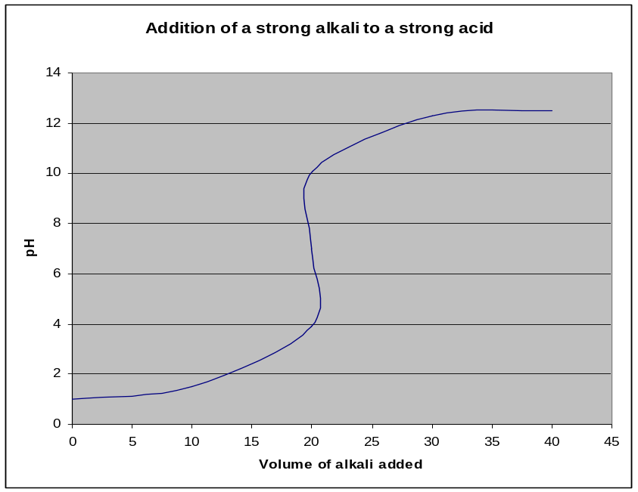

2. pH changes during weak acid - strong alkali titrations

If 0.1M NaOH is added dropwise to 20 cm³ of 0.1M CH₃COOH (2 x 10⁻³ moles), the change in pH of the solution can be calculated by considering the reaction taking place.

Before the addition of NaOH, the pH of the solution is 2.9.

After the addition of 10 cm³ (1 x 10⁻³ moles) of 0.1M NaOH:
NaOH + CH₃COOH → CH₃COONa + H₂O
Before: 1 x 10⁻³ 2 x 10⁻³ -
After: - 1 x 10⁻³ 1 x 10⁻³ Total volume = 30 cm³.

The solution now contains a mixture of a weak acid (CH₃COOH) and its conjugate base (CH₃COO⁻). It thus behaves as a buffer solution. The pH of the mixture can thus be calculated by considering the relative concentrations of the CH₃COOH and CH₃COO.
K_{a} = [H₃O⁺][CH₃COO⁻] so [H₃O⁺] = K_{a}[CH₃COOH] = 1.7 x 10⁻⁵ M and pH = 4.8
[CH₃COOH] [CH₃COO⁻]

After the addition of 19.95 cm³ (1.995 x 10⁻³ moles) of 0.1M NaOH:
(ie 1 drop before the end-point)
NaOH + CH₃COOH → CH₃COONa + H₂O
Before: 1.995 x 10⁻³ 2 x 10⁻³ -
After: - 5 x 10⁻⁶ 1.995 x 10⁻³ Total volume = 39.95 cm³.

[H₃O⁺] = K_{a} x (5 x 10⁻⁶/0.3995) pH = 7.4
(1.995 x 10⁻³/0.03995)

After the addition of 20.05 cm³ (2.005 x 10⁻³ moles) of 0.1M NaOH:
(ie 1 drop after the end-point)
NaOH + CH₃COOH → CH₃COONa + H₂O
Before: 2.005 x 10⁻³ 2 x 10⁻³ -
After: 5 x 10⁻⁶ - 2 x 10⁻³ Total volume = 40.05 cm³.

[OH⁻] = 5 x 10⁻⁶ = 1.25 x 10⁻⁴ M, so [H₃O⁺] = 8.0 x 10⁻¹¹ M pH = 10.1
0.04005

The pH of the solution during a weak acid - strong alkali titration therefore changes from around 7 to 10 over two drops at the end-point.

A titration curve for a weak acid - strong alkali titration can be sketched as follows:

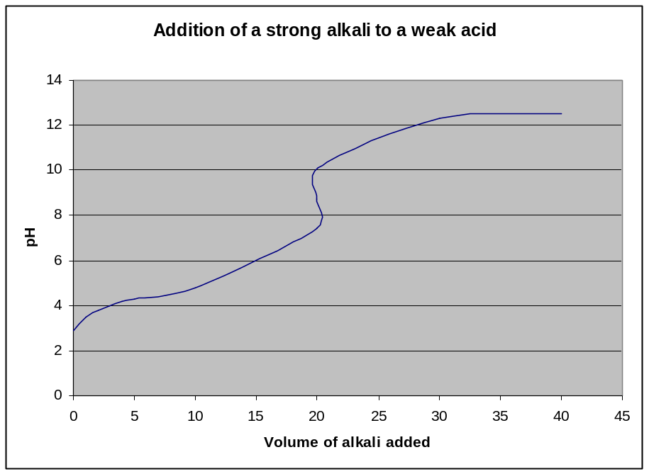

Note that the pH increases fairly fast at the beginning of the titration, until there is enough of the salt formed for an effective buffer solution.

The end-point of the titration is the mid-point of the vertical section of the graph.

Note that in this titration the pH of the solution at the end-point is not 7. The ethanoate ion is basic: CHCOO⁻(aq) + H₂O(l) == CH₃COOH(aq) + OH⁻(aq)
The pH of this solution at the end-point is between 8 and 9

- Strong acid - weak alkali titrations

If 0.1M NH₃ is added to 20 cm³ 0.1M HCl, the mixture behaves in a similar way to a strong acid - strong alkali titration until the end-point is reached.

After the end-point, the solution contains a mixture of NH₄⁺ and NH₃ and thus behaves as a buffer solution.

The pH of the solution during a strong acid - weak alkali titration changes from around 4 to 7 at the end-point.

A titration curve for a strong acid - weak alkali titration can be sketched as follows:

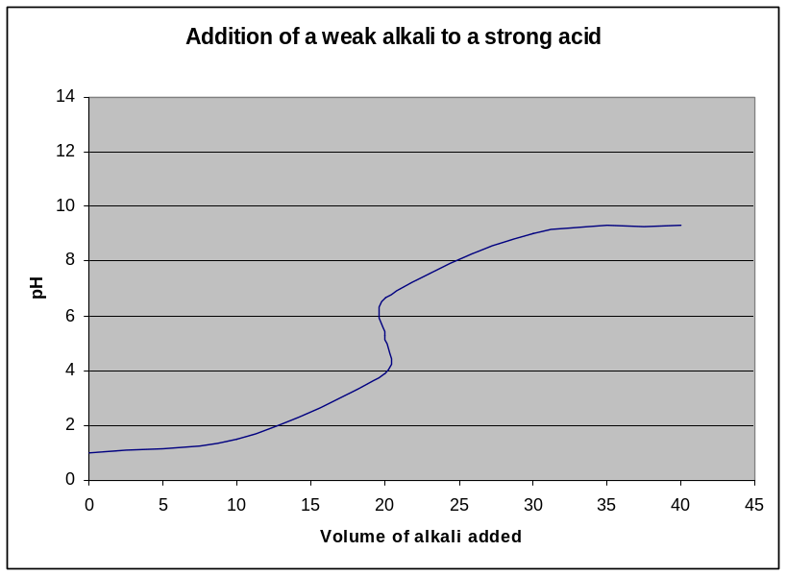

The solution at the end-point contains 0.05M NH₄Cl. It is not neutral, since the NH₄⁺ ion is acidic: NH₄⁺(aq) + H₂O(l) → NH₃(aq) + H₃O⁺(aq)

The pH at the end-point is between 5 and 6.

- Weak acid - weak alkali titrations

Weak acid - weak alkali titrations behave as buffer solutions throughout the titration. Unlike titrations involving strong acids or strong alkalis, there is no dramatic pH change at the end-point. The pH of the end-point is usually around 7, but it depends on the relative strengths of the acid and the alkali.

A titration curve for a weak acid - weak alkali titration can be sketched as follows:

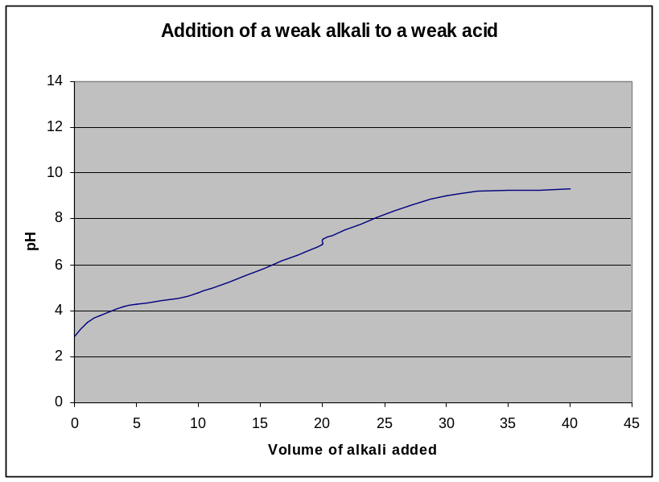

The titration curves for all the different possible titrations can be sketched on the same graph as follows:

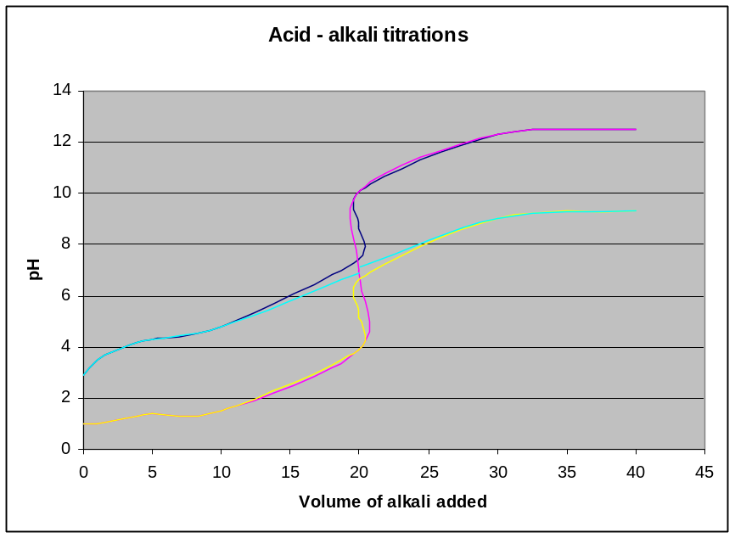

SUMMARY OF ACID-ALKALI TITRATION CURVES

The titration curves for all the different possible titrations can be sketched on the same graph as follows:

Type of titration | pH at end-point | pH change at end-point
Strong acid - strong alkali | 7.0 | 4 to 10
Weak acid - strong alkali | Approx 8.5 | 7 to 10
Strong acid - weak alkali | Approx 5.5 | 4 to 7
Weak acid - weak alkali | Approx 7 | No sudden change

- Half -neutralisation

A weak acid is half-neutralised when exactly half the volume of alkali required for neutralisation has been added.

Eg HA + OH⁻(aq) → A⁻(aq) + H₂O(l)
If 0.5 moles of OH⁻ ions is added to 1 mole of HA, half of the acid will be converted into its salt.

HA + OH⁻(aq) → A⁻(aq) + H₂O(l)
Initially: 1 0.5
After reaction 0.5 - 0.5

At half-neutralisation the number of moles, and hence concentration, of the salt and acid will be the same. [HA] = [A⁻]

Given that K_{a} = [H₃O⁺][A⁻] [H₃O⁺] = K_{a}[HA]
[HA] [A⁻]

If [HA] = [A⁻] then [H₃O⁺] = K_{a} and therefore pH = pK_{a}.

Therefore at half-neutralisation: [H₃O⁺] = K_{a} and pH = pK_{a}.

at half-neutralisation: pH = pK_{a}

The K_{a} of an acid can be deduced from a graph of pH against volume of alkali added.
The pH of the mixture after exactly half the required amount of alkali has been added corresponds to the pK_{a} of the acid.

You calculate the K_{a} of the acid as follows:

The end-point of the titration is the centre of the steep vertical section of the curve.

This occurs at 20 cm³ in this case.

Therefore half-neutralisation occurs at 10 cm³ in this case.

The pH at half-neutralisation is 4.7.

So the pK_{a} of the acid is 4.7

So the K_{a} of the acid = 10^{-4.7} = 1.7 x 10⁻⁵ moldm⁻³.

- Titrations with polybasic acids

When polybasic acids are titrated against strong alkalis, the reaction proceeds through more than one stage.

Eg H₂SO₄(aq) + OH⁻(aq) → HSO₄⁻(aq) + H₂O(l)
HSO₄⁻(aq) + OH⁻(aq) → SO₄²⁻(aq) + H₂O(l)

These reactions do not occur simultaneously – they take place one at a time.

Each of these stages has its own end-point, and thus the reaction will have two end-points.

Eg if 20 cm³ 0.1M H₂SO₄ is titrated against 0.1M NaOH, the first end-point will be reached after 20 cm³ NaOH has been added and the second end-point will be reached after 40 cm³ NaOH has been added.

The titration curve for the above titration can be sketched as follows:

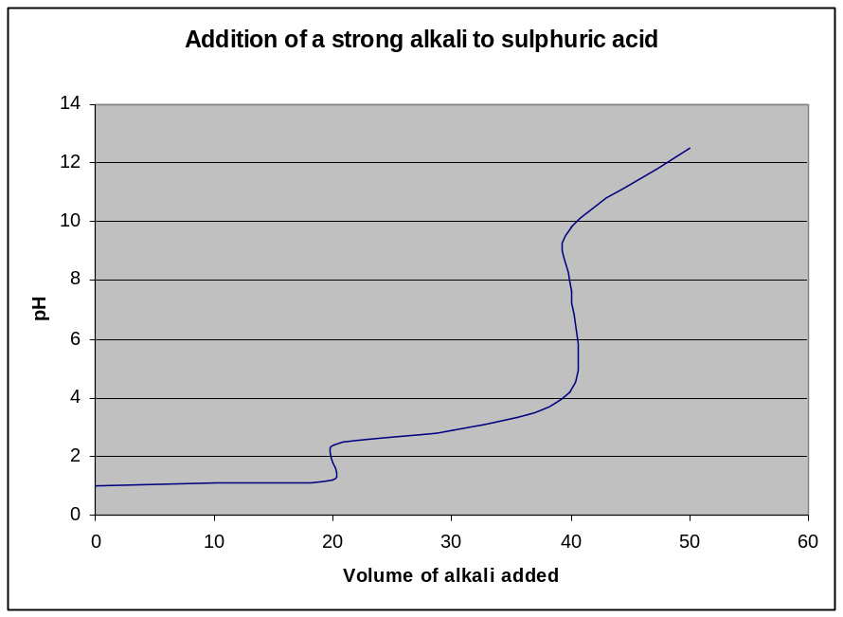
ACID-BASE INDICATORS

1. Theory of indicators

An acid-base indicator is a weak acid which dissociates to give an anion of a different colour.
Consider a weak acid HIn: HIn(aq) + H₂O(l) == H₃O⁺(aq) + In⁻(aq)
Colour 1 Colour 2

HIn and its conjugate base In⁻ are different colours. The colour of the solution depends on the relative concentrations of the two species.

If the solution is strongly acidic, the above equilibrium will be shifted to the left and Hin will dominate. Colour 1 will thus dominate. If the solution is strongly alkaline, the above equilibrium will shift to the right and In⁻ will dominate. Colour 2 will thus dominate.
The colour of the indicator thus depends on the pH of the solution.

The colour will not change suddenly at a certain pH, but will change gradually over a pH range. The colour of the indicator depends on the ratio of [HIn] to [In⁻].

In general, if [HIn]/[In⁻] > 10, then colour 1 will dominate. If [In⁻]/[Hin] > 10, then colour 2 will dominate. The pH at which these transitions will occur depends on the K_{In} of the indicator.
K_{In} = [H₃O⁺][In⁻] so [H₃O⁺] = K_{In}[HIn]
[HIn] [In⁻]

If [H₃O⁺] > 10 x K_{In}, then [HIn]/[In⁻] > 10 and colour 1 dominates.
If [H₃O] < 0.1 x K_{In}, then [Hin]/[In⁻] < 0.1 and colour 2 dominates.
At intermediate H₃O⁺ concentrations, neither colour dominates.

K_{In} values are often expressed as pK_{In} values, where pK_{In} = -log₁₀K_{In}.

This equation can also be expressed in terms of pH:

pH = pK_{In} - log₁₀[HIn]/[In⁻]

pH = pK_{In} + log₁₀[In⁻]/[HIn]

For colour 1 to dominate, [In⁻]/[HIn] < 0.1 so pH must be less than pK -1.
For colour 2 to dominate, [In⁻]/[HIn] > 10 so pH must be greater than pK +1.

So the colour of the indicator changes over the pH range pK_{In} ± 1
Eg If the K_{a} of an indicator is 1.0 x 10⁻⁵ moldm⁻³.
If [H₃O⁺] > 1 x 10⁻⁴ (pH < 4), then [HIn]/[In⁻] > 10 and colour 1 dominates.
If [H₃O⁺] < 1 x 10⁻⁶ (pH > 6), then [Hin]/[In⁻] < 0.1 and colour 2 dominates.
If the pH is between pH 4 and 6, then neither colour dominates.

The pK_{In} values of some indicators is shown below:

Indicator | Colour in acid | Colour in alkali | pK_{a} | pH range of colour change
Thymol blue | Red | Yellow | 1.7 | 1.2 - 2.8
Methyl orange | Red | Yellow | 3.7 | 3.2 - 4.4
Methyl red | Red | Yellow | 5.1 | 4.2 - 6.3
Litmus | Red | Blue | 6.3 | 5.0 - 8.0
Phenolphthalein | Colourless | Pink | 9.3 | 8.2 - 10.0

2. Use of indicators

Indicators are used in acid - alkali titrations in order to find the end-point of the titration.
If they are to determine the end-point accurately, they must undergo a complete colour change at the end-point. This means that the pH range of the colour change must fall completely within the pH range of the end-point. Not all indicators can therefore be used for all titrations, and indicators must be chosen carefully so that the pH range of the colour change matches that of the pH range at the end-point.

The titration curves of various different types of titration are shown below:

- In strong acid - strong alkali titrations, the pH changes from 4 to 10 at the end-point so a suitable indicator must change colour within this range.

Methyl red, litmus and phenolphthalein are suitable indicators for these titrations. Methyl orange is not ideal but it shows a significant enough colour change at the end point to be widely used.

- In weak acid - strong alkali titrations, the pH changes from 7 to 10 at the end-point so a suitable indicator must change colour within this range.

Phenolphthalein is only suitable indicator for weak acid - strong alkali titrations that is widely available.

- In strong acid - weak alkali titrations, the pH changes from 4 to 7 at the end-point so a suitable indicator must change colour within this range.

Methyl red is the most suitable indicator for these titrations. However methyl orange is often used since it shows a significant enough colour change at the end-point and is more widely available than methyl red.

- In weak acid -weak alkali titrations, there is no sudden pH change at the end-point and thus there are no suitable indicators for these titrations. The end-points of these titrations cannot be easily determined.

When carrying out these titrations, only one or two drops of indicators should be used since they are themselves acidic and will themselves influence the end-point if too much is added.

An indicator is suitable for a titration if the most part of the pH range over which it changes colour falls within the pH change at the end-point of the titration.

